**CONTENTS**

**ABSTRACT 2**

**CHAPTER 1**

**INTRODUCTION 3-9**

**CHAPTER 2**

**SYSTEM DESCRIPTION 10-13**

**CHAPTER 3**

**LATEST RESEARCH 14**

**CHAPTER 4**

**CURRENT STATUS 15**

**CHAPTER 5**

**IMPORTANCE AND APPLICATIONS 16-18**

**CHAPTER 6**

**FUTURE WORK 19**

**CHAPTER 7**

**CONCLUSION 20**

**CHAPTER 8**

**REFERENCES 21**

**ABSTRACT**

WISENET is a wireless sensor network that monitors the environmental conditions such as light, temperature, and humidity. This network is comprised of nodes called “motes” that form an ad-hoc network to transmit this data to a computer that function as a server. The server stores the data in a database where it can later be retrieved and analyzed via a web-based interface. The network works successfully with an implementation of one sensor motes.

**CHAPTER 1**

**INTRODUCTION TO WISENET**

The first goal of WISENET is to create a new hardware platform to take advantage of newer microcontrollers with greater functionality and more features. This involves selecting the hardware, designing the motes, and porting TinyOS. Once the platform is completed and TinyOS was ported to it, the next stage is to use this platform to create a small-scale system of wireless networked sensors.

Wireless sensor-actuator networks can provide the ability to continuously monitor the integrity of structures in real-time, detect damage at an early stage, and provide robustness in the case of catastrophic failures with a fraction of cost associated with today’s wired networks. However, sensor-actuator networks require a new paradigm of computing—one, which explicitly addresses less capable hardware, unreliable communication with, limited bandwidth, and severe energy constraints. The algorithms and software tools will facilitate monitoring and protection of civil structures using such networks.

Smart environments represent the next evolutionary development step in building, utilities, industrial, home, shipboard, and transportation systems automation. Like any sentient organism, the smart environment relies first and foremost on sensory data from the real world. Sensory data comes from multiple sensors of different modalities in distributed locations. The smart environment needs information about its surroundings as well as about its internal workings; this is captured in biological systems by the distinction between *exteroceptors* and *proprioceptors.*

The challenges in the hierarchy of: detecting the relevant quantities, monitoring and collecting the data, assessing and evaluating the information, formulating meaningful user displays, and performing decision-making and alarm functions are enormous. The information needed by smart environments is provided by Distributed Wireless Sensor Networks, which are responsible for sensing as well as for the first stages of the processing hierarchy. The importance of sensor networks is highlighted by the number of recent funding initiatives, including the DARPA SENSIT program, military programs, and NSF Program Announcements.

The figure shows the complexity of wireless sensor networks, which generally consist of a data acquisition network and a data distribution network, monitored and controlled by a management center. The plethora of available technologies makes even the selection of components difficult, let alone the design of a consistent, reliable, robust overall system.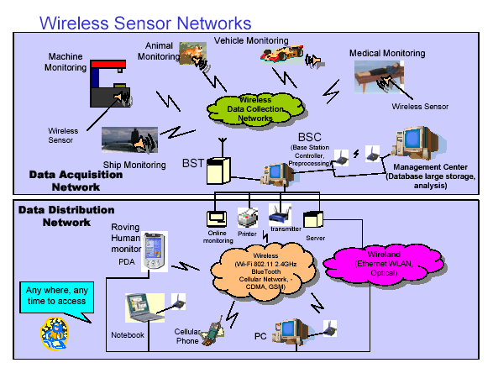

The study of wireless sensor networks is challenging in that it requires an enormous breadth of knowledge from an enormous variety of disciplines. In this chapter we outline communication networks, wireless sensor networks and smart sensors, physical transduction principles, commercially available wireless sensor systems, selforganization, signal processing and decision-making, and finally some concepts for home automation.

**COMMUNICATION NETWORKS**

The study of communication networks can encompass several years at the college or university level. To understand and be able to implement sensor networks, however, several basic primary concepts are sufficient.

**Network Topology**

The basic issue in communication networks is the transmission of messages to achieve a prescribed message throughput (Quantity of Service) and Quality of Service (QoS). QoS can be specified in terms of message delay, message due dates, bit error rates, packet loss, economic cost of transmission, transmission power, etc. Depending on QoS, the installation environment, economic considerations, and the application, one of several basic network topologies may be used.

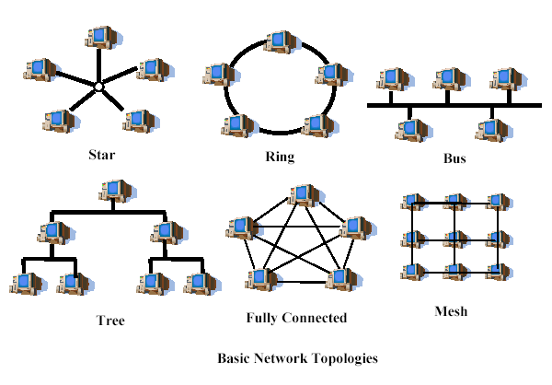

**Fully connected networks** suffer from problems of NP-complexity [Garey 1979]; as additional nodes are added, the number of links increases exponentially. Therefore, for large networks, the routing problem is computationally intractable even with the availability of large amounts of computing power.

**Mesh networks** are regularly distributed networks that generally allow transmission only to a node’s nearest neighbors. The nodes in these networks are generally identical, so that mesh nets are also referred to as peer-to-peer (see below) nets. Mesh nets can be good models for large-scale networks of wireless sensors that are distributed over a geographic region, e.g. personnel or vehicle security surveillance systems.

All nodes of the **star topology** are connected to a single hub node. The hub requires greater message handling, routing, and decision-making capabilities than the other nodes. If a communication link is cut, it only affects one node. However, if the hub is incapacitated the network is destroyed. In the **ring topology** all nodes perform the same function and there is no leader node. Messages generally travel around the ring in a single direction. However, if the ring is cut, all communication is lost. The **self-healing ring network** (SHR) shown has two rings and is more fault tolerant.

In the **bus topology**, messages are broadcast on the bus to all nodes. Each node checks the destination address in the message header, and processes the messages addressed to it. The bus topology is passive in that each node simply listens for messages and is not responsible for retransmitting any messages.

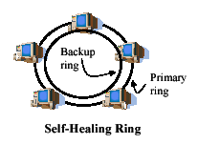

**1.2 Communication Protocols and Routing**

The topics of communication protocols and routing are complex and require much study. Some basics useful for understanding sensor nets are presented here. **Headers.** Each message generally has a *header* identifying its source node, destination node, length of the data field, and other information. This is used by the nodes in proper routing of the message. In encoded messages, parity bits may be included. In *packet routing networks*, each message is broken into *packets* of fixed length. The packets are transmitted separately through the network and then reassembled at the destination. The fixed packet length makes for easier routing and satisfaction of QoS. Generally, voice communications use circuit switching, while data transmissions use packet routing.

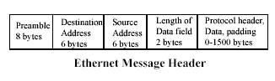

separately through the network and then reassembled at the destination. The fixed packet length makes for easier routing and satisfaction of QoS. Generally, voice communications use circuit switching, while data transmissions use packet routing.

**1.3 Switching**

Most computer networks use a *store-and-forward* switching technique to control the flow of information. Then, each time a packet reaches a node, it is completely buffered in local memory, and transmitted as a whole. More sophisticated switching techniques include *wormhole*, which splits the message into smaller units known as flow control units or flits. The header flit determines the route. **Multiple Access Protocols**. When multiple nodes desire to transmit, protocols are needed to avoid collisions and lost data. In the ALOHA scheme, first used in the 1970’s at the University of Hawaii, a node simply transmits a message when it desires. If it receives an acknowledgement, all is well. If not, the node waits a random time and retransmits the message.

**Open Systems Interconnection Reference Model (OSI/RM).**

The International Standards Organization (ISO) OSI/RM architecture specifies the relation between messages transmitted in a communication network and applications programs run by the users. The development of this open standard has encouraged the adoption by different developers of standardized compatible systems interfaces. The figure shows the seven layers of OSI/RM. Each layer is self-contained, so that it can be modified without unduly affecting other layers. The Transport Layer provides error detection and correction. Routing and flow control are performed in the Network Layer. The Physical Layer represents the actual hardware communication link interconnections. The Applications Layer represents programs run by users.

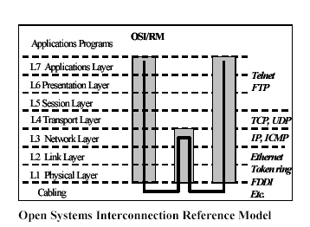

**Routing.** Since a distributed network has multiple nodes and services many messages, and each node is a shared resource, many decisions must be made. There may be multiple paths from the source to the destination. Therefore, message routing is an important topic. The main performance measures affected by the routing scheme are throughput (quantity of service) and average packet delay (quality of service). Routing schemes should also avoid both deadlock and livelock (see below).

**Fixed routing schemes**

often use Routing Tables that dictate the next node to be routed to, given the current message location and the destination node. Routing tables can be very large for large networks, and cannot take into account real-time effects such as failed links, nodes with backed up queues, or congested links.

**Adaptive routing schemes** depend on the current network status and can take into account various performance measures, including cost of transmission over a given link, congestion of a given link, reliability of a path, and time of transmission. They can also account for link or node failures.

**Power Management**

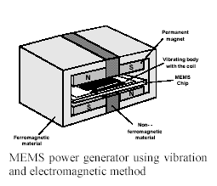With the advent of ad hoc networks of geographically distributed sensors in remote site environments (e.g. sensors dropped from aircraft for personnel/vehicle surveillance), there is a focus on increasing the lifetimes of sensor nodes through power generation, power conservation, and power management. Current research is in designing small MEMS (microelectromechanical systems) RF components for transceivers, including capacitors, inductors, etc. The limiting factor now is in fabricating microsized inductors. Another thrust is in designing MEMS power generators using technologies including solar, vibration (electromagnetic and electrostatic), thermal, etc.

**CHAPTER 2**

**SYSTEM DESCRIPTION**

There are two primary subsystems (Data Analysis and Data Acquisition) comprised of three major components (Client, Server, Sensor Mote Network).

**Primary Subsystems:**

There are two top-level subsystems –

***Data Analysis***

***Data Acquisition.***

**Data Analysis:**

This subsystem is software-only (relative to WISENET). It relied on existing Internet and web (HTTP) infrastructure to provide communications between the Client and Server components

**Data Acquisition:**

The purpose of this subsystem is to collect and store environmental data for later processing by the Data Analysis subsystem.

**System Components:**

System components are *Client, Server, and Sensor Mote Network.*

## CLIENT SERVER SENSOR MOTE NETWORK

HTTP RS232 SERIAL

TCP/IP TCP/IP

980MHZ RF Comm.

TCP/IP

Office2

Gateway

Internet

Office1

HTTP

Server

System

Wise DB

Lab B

Lab A

Web

Program

Web

Browser

SQL

Database

**Data Analysis**

## Data Analysis Subsystem Data Acquisition

## Client:

The Client component is necessary but external to the development of WISENET. That is, any computer with a web browser and Internet access could be a Client. It served only as a user interface to the Data Analysis subsystem.

**CLIENT**

### Inputs &

**Outputs**

**USER SERVER Requests WEB page Requested WEB page**

**USER SERVER**

**Requested WEB page Requests WEB page**

#### 

#### Figure 2: Client Component Inputs/Outputs

**Server:**

The Server is a critical component as the link between the Data Acquisition and Data Analysis subsystems. On the Data Analysis side, an web (HTTP) server hosting a web application. When a page request came in, the web server executes the web application, which retrieved data from the database, processes it, and returns a web page that the web server transmitted to the Client. For the Data Acquisition system there is a daemon (WiseDB) running to facilitate communication with the Sensor Mote Network.

**SERVER**

### Inputs &

**Outputs**

**CLIENT SENSOR NETWORK**

**WEB page Requests** **Data packets**

(**Via GATEWAY MOTE)**

**CLIENT** **SENSOR NETWORK**

**Requested WEB page Commands**

**Figure 3: Server Components Inputs/Outputs**

**Sensor Motes:**

The primary focus of WISENET is the development of the Sensor Mote Network component. It is the component responsible for collecting and transmitting raw environmental data to the Server. There is also the potential for the motes to receive commands from the Server, although that functionality may not be implemented in WISENET. Uses for this feature would include server-based synchronization and wireless network reprogramming. 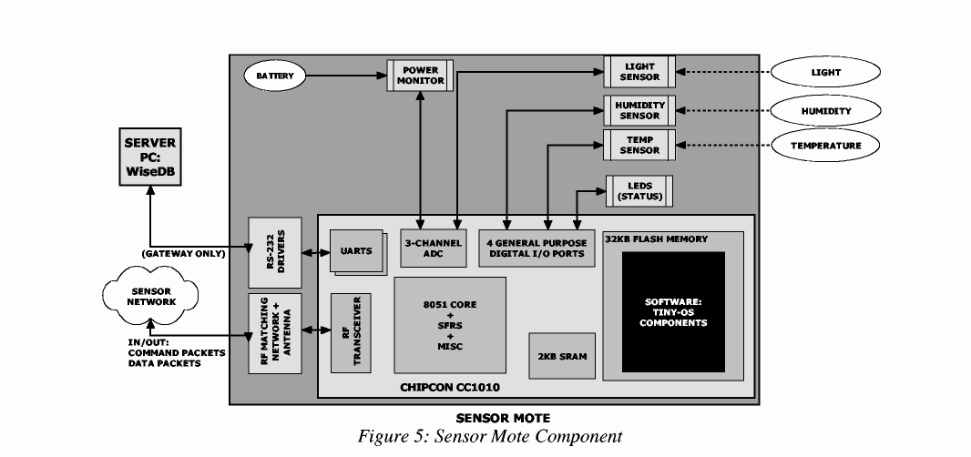

**2.1 Hardware Design:**

The selection of components for the sensor motes is a critical process in the development of WISENET. Great functionality and low power are two of the highest priorities in evaluating the fitness of both the microcontroller and the sensor candidates. WISENET is introduced to the new state-of-the-art Chipcon CC1010 microcontroller with integrated RF transceiver. After a little research it was decided the CC1010 would make the perfect microcontroller.

It had the following feature list:

1. Optimized 8051-core

2. Active (14.8 mA), Idle (29 _A) and sleep (0.2 _A) power modes

3. 32 kB flash memory

4. 2 kB +128 bytes SRAM

5. Three channel 10-bit ADC

6. Four timers / Two PWM's

7. Hardware DES encryption/decryption

8. Hardware random bit-generator

9. Fully integrated UHF RF transceiver (433 MHz / 868 MHz nominal)

_ Programmable output power (-20 to 10 dBm)

_ Low current consumption (11.9 mA for RX, 17.0 mA for TX at 0dBm)

_ RSSI output that can be sampled by the on-chip ADC

**2.2** **Software design-shelf products:**

The server using for WISENET should have four commercial off the shelf applications installed on it that worked together to create the Data Analysis portion of the Server component. Apache, MySQL, and PHP are open-source products freely available on the Internet. In addition, Chart-Director the trial version of the commercial application Chart-Director was used.

**Apache** is a standard web-server, which makes a web document available on the Internet.

**PHP** is a web programming language, which allows dynamic web-pages. It should also be designed to use along with a database and included many built-in functions for interfacing with MySQL.

**MySQL** is a database that can contain any type of data and is accessed by a TCP/IP (Internet) call.

**Chart-Director** is a program that generates a graph from raw data. It is available in many languages such as PHP, ASP, C++, and others.

**CHAPTER 3**

**LATEST RESERACH**

**International Research Journal**

**New Wisenet Viewer 1.0 from Hanwha Techwin makes managing multiple video sources easy**

Hanwha Techwin has launched Wisenet Viewer 1.0, a new NVR/DVR viewer that makes it simple to view and manage different video sources through one interface.  Wisenet Viewer 1.0 is designed to make video management easy and works with all Wisenet recorders. It removes the need for a dedicated server to manage all video sources, leading to cost reductions and helping to preserve existing investments without new licences or replacing all recorders.

**Multiple video views**

Through Wisenet Viewer 1.0, operators can view multiple applications on multiple monitors including web pages and images, monitor live video, search and play recorded video and set event rules like alarms, video and audio analytics, face detection, tampering and object detection. The software supports Windows and macOS operating systems.

**Easily adapted**

Operators can easily adapt Wisenet Viewer 1.0 to their needs with custom layouts that can include multiple tabs and windows. Video files can be easily organised and resized with a few clicks. User permissions can also be set and removed through the software.

**Raising the bar**

Uri Guterman, Head of Product & Marketing for Hanwha Techwin Europe said: “Our aim is to continuously raise the bar for video surveillance and help our customers innovate with video technology. The Wisenet Viewer 1.0 will support these goals, making it easier for organisations to manage different video streams, triggered events and, overall, gain greater intelligence of events happening on-the-ground.”

Wisenet Viewer 1.0 is easy to set up and saves time and maintenance overheads. It is free when organisations buy a Wisenet recorder.

**CHAPTER 4**

**CURRENT STATUS**

**WISENET AUTOMATION PRIVATE LIMITED**

Wisenet Automation Private Limited is an Indian Non-Government Company. It's a private company and is classified as'company limited by shares'.  
  
Company's authorized capital stands at Rs 10.0 lakhs and has 10.0% paid-up capital which is Rs 1.0 lakhs.  
  
Wisenet Automation Private Limited is majorly in Business Services business and currently, company operations are active.  
  
Company is registered in Hyderabad (Andhra Pradesh) Registrar Office. Wisenet Automation Private Limited registered address is WISENET AUTOMATION PRIVATE LIMITED Rishi Sagar Apartments, 15-15-2/1, Flat No-C5, 530002 Maharanipeta-Vishakhapatnam.

**Wisenet Automation Private Limited Details**

|  |  |
| --- | --- |
| **CIN** | U74999AP2017PTC104937 |
| **Status** | ACTIVE |
| **Company Category** | Company Limited by Shares |
| **Company Sub-category** | Indian Non-Government Company |
| **Company Class** | Private |
| **Business Activity** | Business Services |
| **Authorized Capital** | 10.0 lakhs |
| **Paid-up Capital** | 1.0 lakhs |
| **Paid-up Capital %** | 10.0 |
| **Registrar Office City** | Hyderabad |
| **Registered State** | Andhra Pradesh |
| **Registration Date** | 03 Feb, 2017 |

**CHAPTER 5**

**IMPORTANCE AND APPLICTIONS**

**Area monitoring**

Area monitoring is a common application of WSNs. In area monitoring, the WSN is deployed over a region where some phenomenon is to be monitored. A military example is the use of sensors to detect enemy intrusion; a civilian example is the [geo-fencing](https://en.wikipedia.org/wiki/Geo-fence) of gas or oil pipelines.

**Health care monitoring**

There are several types of sensor networks for medical applications: implanted, wearable, and environment-embedded. Implantable medical devices are those that are inserted inside the human body. Wearable devices are used on the body surface of a human or just at close proximity of the user. Environment-embedded systems employ sensors contained in the environment. Possible applications include body position measurement, location of persons, overall monitoring of ill patients in hospitals and at home.

**Habitat Monitoring**

Wireless sensor networks have been used to monitor various species and habitats, beginning with the Great Duck Island Deployment, including marmots, cane toads in Australia and zebras in Kenya.

**Environmental/Earth sensing**

There are many applications in monitoring environmental parameters,[[11]](https://en.wikipedia.org/wiki/Wireless_sensor_network#cite_note-11) examples of which are given below. They share the extra challenges of harsh environments and reduced power supply.

**Air quality monitoring**

Experiments have shown that personal exposure to [air pollution](https://en.wikipedia.org/wiki/Air_pollution) in cities can vary a lot.[[12]](https://en.wikipedia.org/wiki/Wireless_sensor_network#cite_note-12) Therefore, it is of interest to have higher temporal and spatial resolution of [pollutants](https://en.wikipedia.org/wiki/Pollutants) and [particulates](https://en.wikipedia.org/wiki/Particulates). For research purposes, wireless sensor networks have been deployed to monitor the concentration of [dangerous gases for citizens](https://en.wikipedia.org/wiki/Air_pollution) (e.g., in [London](https://en.wikipedia.org/wiki/London))However, sensors for gases and particulate matter suffer from high unit-to-unit variability, cross-sensitivities, and (concept) drift Moreover, the quality of data is currently insufficient for trustworthy decision-making, as field calibration leads to unreliable measurement results, and frequent recalibration might be required. A possible solution could be blind calibration or the usage of mobile references

**Forest fire detection**

A network of Sensor Nodes can be installed in a forest to detect when a [fire](https://en.wikipedia.org/wiki/Forest_fire) has started. The nodes can be equipped with sensors to measure temperature, humidity and gases which are produced by fire in the trees or vegetation. The early detection is crucial for a successful action of the firefighters; thanks to Wireless Sensor Networks, the fire brigade will be able to know when a fire is started and how it is spreading.

**Landslide detection**

A [landslide](https://en.wikipedia.org/wiki/Landslide) detection system makes use of a wireless sensor network to detect the slight movements of soil and changes in various parameters that may occur before or during a landslide. Through the data gathered it may be possible to know the impending occurrence of landslides long before it actually happens.

**Water quality monitoring**

[Water quality](https://en.wikipedia.org/wiki/Water_quality) monitoring involves analyzing water properties in dams, rivers, lakes and oceans, as well as underground water reserves. The use of many wireless distributed sensors enables the creation of a more accurate map of the water status, and allows the permanent deployment of monitoring stations in locations of difficult access, without the need of manual data retrieval.

**Natural disaster prevention**

Wireless sensor networks can be effective in preventing adverse consequences of [natural disasters](https://en.wikipedia.org/wiki/Natural_disaster), like floods. Wireless nodes have been deployed successfully in rivers, where changes in water levels must be monitored in real time.

**Industrial monitoring**

**Machine health monitoring**

Wireless sensor networks have been developed for machinery condition-based maintenance (CBM) as they offer significant cost savings and enable new functionality.

Wireless sensors can be placed in locations difficult or impossible to reach with a wired system, such as rotating machinery and untethered vehicles.

**CHARECTERISTICS**

The main characteristics of a WSN include

* Power consumption constraints for nodes using batteries or [energy harvesting](https://en.wikipedia.org/wiki/Energy_harvesting). Examples of suppliers are ReVibe Energy and Perpetuum
* Ability to cope with node failures ([resilience](https://en.wikipedia.org/wiki/Resilience_(network)))
* Some mobility of nodes (for highly mobile nodes see [MWSNs](https://en.wikipedia.org/wiki/MWSN))
* Heterogeneity of nodes
* Homogeneity of nodes
* [Scalability](https://en.wikipedia.org/wiki/Scalability) to large scale of deployment
* Ability to withstand harsh environmental conditions
* Ease of use
* [Cross-layer optimization](https://en.wikipedia.org/wiki/Cross-layer_optimization)
* Cross-layer is becoming an important studying area for wireless communications.[[31]](https://en.wikipedia.org/wiki/Wireless_sensor_network#cite_note-Zander-31) In addition, the traditional layered approach presents three main problems:

1. Traditional layered approach cannot share different information among different layers, which leads to each layer not having complete information. The traditional layered approach cannot guarantee the optimization of the entire network.
2. The traditional layered approach does not have the ability to adapt to the environmental change.
3. Because of the interference between the different users, access conflicts, fading, and the change of environment in the wireless sensor networks, traditional layered approach for wired networks is not applicable to wireless networks.

**CHAPTER 6**

**Future Work**

There are a number of future extensions for this WISENET. A few are:

We can expand the sensor mote network by adding more motes. This would allow the

development and testing of advanced network-layer functions, such as multi-hop routing.

By creating a new PCB design that integrates the CC1010EM design with the

sensors and power hardware on a single-board another interesting feature can be developed or adopt a standard expandable plug-in sensor interface in both hardware and software

In researching alternative energy sources to extend mote battery life. Possibilities include solar cells and rechargeable batteries.

##### **CHAPTER 7**

**CONCLUSION**

Wireless sensor networks are getting smaller and faster, increasing their potential applications in commercial, industrial, and residential environments. WISENET, as implemented, represents one commercial application. However, the limit of applications depends only upon the sensors used and the interpretation of the data obtained. As the technology improves and new low-power digital sensors become more readily available, motes will increase functionality without increasing power consumption and will expand the wireless sensing market.

**CHAPTER 8**

**REFERENCES**

**1**.**Atkinson**, **MySQL++: A C++ API for MySQL, vers 1.7.**9,

<http://www.mysql.com/downloads/api-mysql++. html>.

**2.Gay Levis**, **The *nesC* Language: A Holistic Approach to Network Embedded System**s,

<http://today.cs.berkeley.edu/tos/papers/nesc.pdf>.

**3.Mainwaring, Polastre**, et al. **Wireless Sensor Networks for Habitat Monitorin**g,

http://www.cs.berkeley.edu/~polastre/papers/wsna02.pdf

**4**.**Hill, Szewczyk**, et al. **System architecture directions for network sensors,**

http://today.cs.berkeley.edu/tos/papers/tos.pdf

**5**.**Torvmark, Application Note AN017: Low Power Systems Using the CC101**0,

http://www.chipcon.com/files/AN_017_Low_Power_Systems_Using_The_CC1010_1_1.pdf

**6**.**Ye, Heidemann,** et al. **An Energy-Efficient MAC Protocol for Wireless Sensor Network**s,

<http://www.isi.edu/%7Eweiye/pub/smac_infocom.pdf>

For software shelf products downloads, websites are:

[www.apache.org](http://www.apache.org)

[www.php.net](http://www.php.net)

[www.mysql.com](http://www.mysql.com)

[www.advsofteng.com/index.html](http://www.advsofteng.com/index.html)

<http://Internetmaster.com/installtutorial/index.htm>l